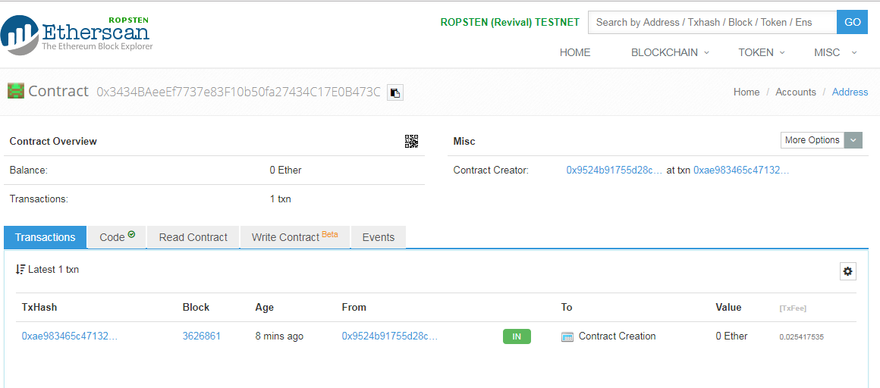

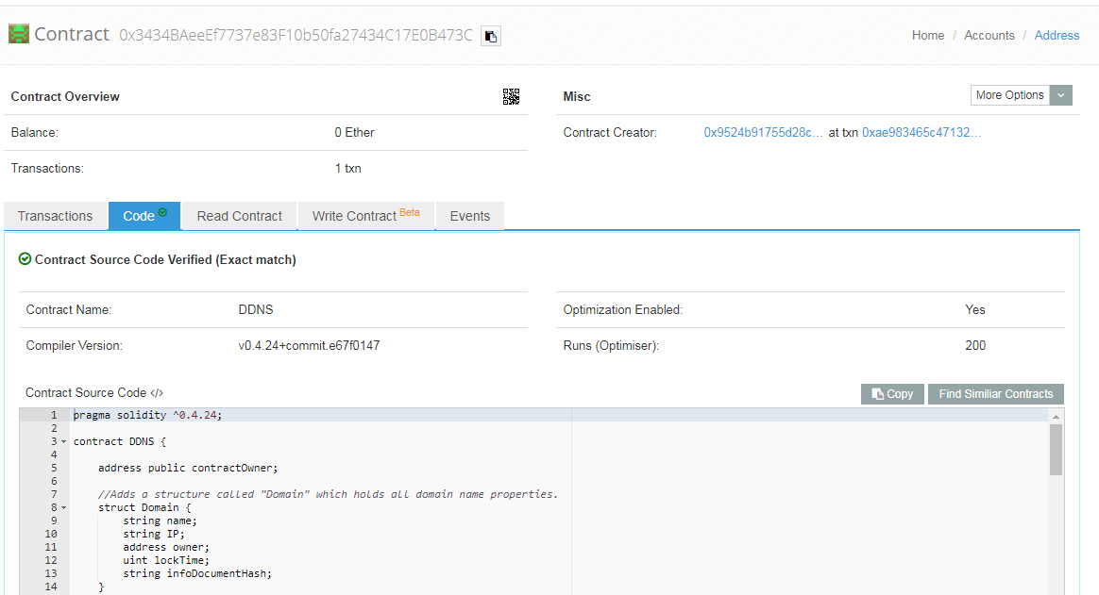

Contract: 0x3434baeeef7737e83f10b50fa27434c17e0b473c

<https://ropsten.etherscan.io/address/0x3434baeeef7737e83f10b50fa27434c17e0b473c>